**RoFin (Adaptive Human Computer Interaction Project)**



***Use Case Specification Document***

**MA-01**

**Mobile App Implementation of RoFin (Adaptive HCI)**

**Version No. 1.0**

**Project Document Revision History**

| **VersionNumber** | **Date** | **Revision Author** | **Description of Revision** |
| --- | --- | --- | --- |
| 1 | 10/16/2024 | Deniz K. Acikbas | Original Revision |

| **Table of Contents** |
| --- |

**1.** **INTRODUCTION 4**

**2.** **USE CASE INFORMATION 4**

2.1 Actors 4

2.2 Use Case Interaction 4

**3.** **TRIGGER 4**

3.1 Camera Initiatilization 4

3.2 LED Glove Initialization 4

**4.** **PRE-CONDITION(S) 4**

4.1 Mobile Application 4

4.2 Camera 4

4.3 LED Gloves 4

**5.** **POST-CONDITION(S) 5**

5.1 Successful Gesture Simulation 5

5.2 Server Exception – Server Processing Error 5

5.3 Server Exception – No Internet Connection 5

5.4 Server Exception – Connection Interrupted 5

5.5 Camera Exception – Camera Hardware Error 5

5.6 Camera Exception – Camera Not Detected 5

5.7 Camera Exception – Connection Not Compatible 5

5.5 Glove Exception – Glove Hardware Error 5

5.6 Glove Exception – Glove Not Detected 5

5.7 Glove Exception – Glove Not Compatible 5

**6.** **USE CASE SWIMLANE (ACTIVITY) DIAGRAM 6**

**7.** **MAIN/BASIC FLOW(S) OF EVENTS (HAPPY PATH) 8**

7.1 Tracking and simulating hands through mobile app (Completed Path) 8

**8.** **ALTERNATE/EXCEPTION FLOW OF EVENTS 9**

8.1 Server Exception 9

8.2 Camera Exception 9

8.3 Glove Exception 9

**9.** **ASSUMPTIONS/BUSINESS RULES INCLUDING NON-FUNCTIONAL REQUIREMENTS 9**

9.1 Functioning Mobile Phone with Camera 9

9.2 Visible Environment 9

**10.** **USE CASE SPECIFICATION REVIEW AND SIGNOFF 10**

# **Introduction**

This document outlines the business requirements for a mobile application that captures and processes hand and finger movements in real-time using built-in mobile cameras with rolling shutter functionality and LED gloves. It focuses on the functional aspects of the application, ensuring clear and effective business operations, while avoiding any technical or IT-related details. The goal is to create a seamless and user-friendly experience for gesture tracking.

A separate Use Case Summary document will tie together all the individual use cases, providing a comprehensive overview of the system. This summary helps ensure that all necessary functions are captured without over-complicating or missing any critical parts of the user experience.

Each use case is developed to strike a balance between being detailed enough to cover essential business needs and simple enough to avoid unnecessary complexity. This ensures that the app’s core functionality is fully addressed without overwhelming the development process.

# **Use Case Information**

## **2.1. Actors**

| Actor Name | Role | Description |
| --- | --- | --- |
| User | Main | Interacts with the mobile application to initiate and stop gesture tracking by performing hand movements. |

## **Use Case Interaction**

This use case, the Mobile App Use Case, is central to the system and interacts with several other functional components. Its predecessor is the setup process for both the camera and LED gloves, which ensures the hardware is ready for tracking. As a successor, the mobile app use case leads into various post-capture processes, such as gesture analysis, data storage, or real-time feedback handling. These interactions ensure that the app operates seamlessly from setup to processing, connecting the essential parts of the user experience.

# **Trigger**

## **3.1. Camera Initialization**

The camera is activated, and the system checks for proper connection and calibration, ensuring it is ready to capture hand and finger movements accurately.

## **LED Glove Initialization**

The LED gloves are powered on and paired with the app, with the system confirming that all sensors are working correctly and are ready for use in gesture tracking.

# **Pre-condition(s)**

## **Mobile Application**

The mobile application must be installed and running on the user's device, with all necessary permissions granted for accessing the camera and Bluetooth functionality.

## **Camera**

The rolling shutter camera must be properly connected to the mobile app, and it should be powered on and ready to capture hand movements.

## **LED Gloves**

The LED gloves must be charged, powered on, and paired with the mobile app, ensuring that all sensors are functioning correctly for gesture tracking.

# **Post-condition(s)**

## **Successful Gesture Simulation**

After the use case is completed, either on a mobile phone or AR/VR device, the system has successfully captured and processed the user’s hand gestures using the LED gloves. The gestures are simulated in real-time, and the data is saved or ready for further analysis.

## **Server Exception – Server Processing Error**

If the server fails to process the gesture data, whether on a mobile phone or AR/VR device, the system will notify the user and attempt to retry the connection or processing.

## **Server Exception – No Internet Connection**

The system detects the absence of an internet connection on the mobile phone or AR/VR device, prompting the user to reconnect or wait until connectivity is restored.

## **Server Exception – Connection Interrupted**

If the connection to the server is interrupted during processing, the system will notify the user on the mobile or AR/VR device and attempt to reestablish the connection.

## **Camera Exception – Camera Hardware Error**

A hardware malfunction in the camera triggers an error message on the mobile phone or AR/VR device, prompting the user to resolve the issue or retry the connection.

## **Camera Exception – Camera Not Detected**

If the system cannot detect the camera, it will alert the user to check the connection and ensure the camera is properly attached and configured on the mobile or AR/VR device.

## **Camera Exception – Connection Not Compatible**

The system detects that the camera is incompatible with the mobile phone or AR/VR device, providing the user with troubleshooting instructions or alternative options.

## **Glove Exception – Glove Hardware Error**

A hardware issue with the gloves will result in an error message on the mobile phone or AR/VR device, asking the user to check the gloves or restart the system.

## **Glove Exception – Glove Not Detected**

If the system fails to detect the gloves, the user is notified on their mobile or AR/VR device to reconnect or pair the gloves properly with the application.

## **Glove Exception – Glove Not Compatible**

A hardware issue with the gloves will result in an error message on the mobile phone or AR/VR device, asking the user to check the gloves or restart the system.

# **Use Case Swimlane (Activity) Diagram**

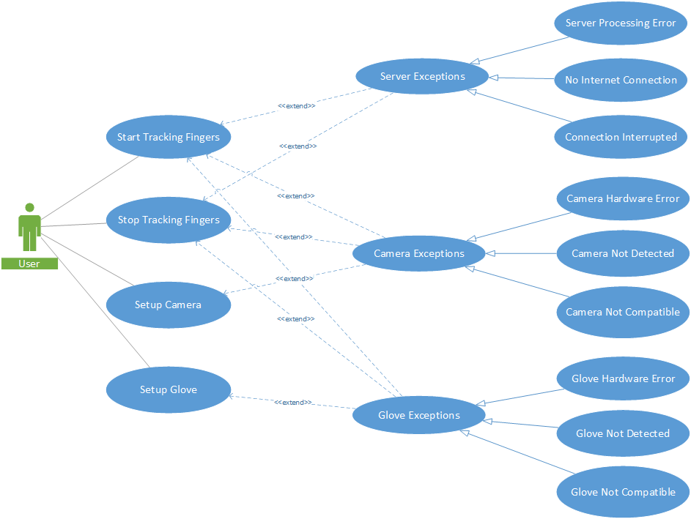

# **Main/Basic Flow(s) of Events (Happy Path)**

## **Tracking and simulating hands through mobile app (Completed Path)**

1. The user opens the mobile app and clicks the "Start Tracking" button.
2. The mobile app triggers the rolling shutter camera and LED gloves to start tracking the user's hand and finger movements.
3. The camera begins capturing real-time frames of the user’s hand gestures and sends the data to the app.
4. The LED gloves' sensors detect the precise finger positions and movements, sending this data to the app via Bluetooth or a wired connection.
5. The mobile app processes the captured data and combines the input from the camera and gloves to create a real-time simulation of the hand movements.
6. The simulated gestures are displayed on the mobile app interface, reflecting the user’s hand and finger movements in real-time.
7. The user can stop tracking at any time by clicking the "Stop Tracking" button, which saves the captured gesture data for further use or analysis.

# **Alternate/Exception Flow of Events**

## **Server Exception**

1. The mobile app attempts to communicate with the server for data processing but encounters an issue.
2. If a **Server Processing Error** occurs, the app notifies the user that the server cannot process the request and suggests trying again later.
3. If **No Internet Connection** is detected, the app informs the user of the lack of connectivity and prompts them to reconnect.
4. If the **Connection is Interrupted** during data transmission, the app attempts to reconnect. If unsuccessful, it notifies the user and pauses further operations.

## **Camera Exception**

1. The app attempts to initialize the camera, but a hardware or connection issue arises.
2. In the case of a **Camera Hardware Error**, the app informs the user that the camera has malfunctioned and suggests checking or reconnecting the device.
3. If the **Camera is Not Detected**, the app notifies the user that the camera is not connected and advises them to verify the connection.
4. If the **Camera is Not Compatible**, the app informs the user that the camera does not meet the system requirements and suggests using a compatible device.

## **Glove Exception**

1. The app attempts to pair or use the LED gloves, but an error occurs.
2. If a **Glove Hardware Error** is detected, the app notifies the user of a malfunction and recommends checking or restarting the gloves.
3. If the **Glove is Not Detected**, the app alerts the user to reconnect the gloves and ensures proper pairing.
4. If the **Glove is Not Compatible**, the app informs the user that the gloves are incompatible and suggests using a different, supported pair of gloves.

# **9. Assumptions/Business Rules including Non-Functional Requirements**

**9.1 Functioning Mobile Phone with Camera**

**Assumption:** The mobile phone being used must have a fully functional camera capable of supporting the application’s real-time gesture tracking features.

**Non-Functional Requirement**: The camera must capture high-quality images at a sufficient frame rate to support smooth, real-time processing of hand gestures without significant lag or distortion.

**9.2 Visible Environment**

# **Assumption:** The user must be in a well-lit environment where the camera can clearly capture hand and finger movements for accurate gesture recognition.

**Non-Functional Requirement**: The system should be able to function in varying lighting conditions, with algorithms that adjust for low light or excessive brightness to ensure accurate gesture detection.

# **Use Case Specification Review and Signoff**

| Review and Signoff of the Use Case Specification | | | |
| --- | --- | --- | --- |
| Name | Project Team Role | Signature | Date |
| Soham Naik | Lead Image Processing & Computer Vision Engineer | [Soham Naik](mailto:sohamn@umich.edu) | 10/16/2024 |
| Deniz Acikbas | Lead Mobile App & VR/AR Engineer | [Deniz Acikbas](mailto:dacikbas@umich.edu) | 10/16/2024 |
| Zaynab Mourtada | Lead Machine Learning Engineer | [Zaynab Mourtada](mailto:zaynabmo@umich.edu) | 10/16/2024 |
| Alan Raj | Lead 3D Visualizer Engineer | [Alan Raj](mailto:alanraj@umich.edu) | 10/16/2024 |
| Xiao Zhang | Client |  | 10/16/2024 |